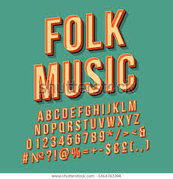
PALMERSTON NORTH FOLK MUSIC CLUB NEWSLETTER
February - June 2021
President’s Finale
“Finale” because this will be my final message as President of our Folk Music Club. I will be stepping down as President and Lesley will also be stepping down as Secretary at the AGM on 16th April. So here are two opportunities for members to step-up to these roles for administering our Club. Please ask Lesley or me what these roles entail, if you’re interested.
On February 12th, the Chinese lunar New Year, we start The Year of the Ox! This follows The Year of the Rat, which was one of anxiety, disruption, and the flexibility of having to adjust to a pandemic Covid-19 world. But we got through all that with the help of the internet! Attendances on Club Nights, towards the end of the year, were amongst the best the Club has had since I’ve been a member.
What’s in store for 2021?
According to Chinese tradition, the Ox denotes hard work, positivity, and honesty. The element of The Year of the Ox is the earth – stability and nourishment. Coincidently, as a Soil Scientist and having the name Craig (from the Gaelic “creag” for rock), I have a special affinity with the “earth”, having spent my working life digging holes, examining soil profiles, constructing soil maps, and writing scientific papers and reports on how to improve the management of our precious soil resources. Papatūānuku, “Mother Earth” in Māori folklore, gives birth to all things, and provides the physical and spiritual basis for life.
“What’s that got to do with Folk Music”? – you ask! Waiata and tangi are derived spiritually from Papatūānuku, so we can relate the whakapapa of our songs and tunes back to “Mother Earth”.
Your Committee have held our first meeting for 2021, coming up with another series of varied themes for the first 4 months. Something for everyone, with a roster of helpers for hosting, supper, and the door. Please let Secretary Lesley or another Committee Member know, in advance, if you are unable to do a duty you’ve been assigned to.
Unfortunately, overseas folkies have had to cancel the concerts we had ‘pencilled-in’. We’re now on the hunt for popular local folk musicians to provide us with some concerts, scattered through the year. The programme ‘til June 18th is thus somewhat of a draft, as we may be swapping a theme or two for concerts, if we are successful in obtaining guest musicians for concerts.
Let’s look forward to another fun, sociable, and enjoyable 2021 of folk music on Friday nights at the Theosophical Hall. See you there.
Curtain! Fast Music! Lights! Ready for the last finale! Great! The show looks good, the show looks good!
Florenz Ziegfeld

~~~~~~~~~~~~~~~~~~~~~~~~~~~~~~~~~~~~~~~~~~~~~~~~~~~~~~~~~~~~~~~~~~~~~~~~~~~~~~~~~~~~~~~~~~~~~~~
Subscriptions for the year (1st April to 31st March) – single: $20; family: $30.
Subscriptions for half year (September - March) – single: $10; family $15
Pay to David on club nights or Direct bank transfer, please ensure your name is in the details:
Bank Account No.: 02-0719-0137825-00
~~~~~~~~~~~~~~~~~~~~~~~~~~~~~~~~~~~~~~~~~~~~~~~~~~~~~~~~~~~~~~
COMMITTEE
President: Craig Ross 355 3445 drcwross@gmail.com
Secretary: Lesley van Essen 355 9076 l.p.vanessen@gmail.com
Treasurer: David Newman 357 8998 4dnewman@xtra.co.nz
Ruth Filbee rfilbee@xtra.co.nz
Midge Minot midgeminot@gmail.com
Mike O’Regan 327 4037 whitegate99@gmail.com
~~~~~~~~~~~~~~~~~~~~~~~~~~~~~~~~~~~~~~~~~~~~~~~~~~~~~~~~~~~~~~~~~~~~~~~~~~~~~~~~

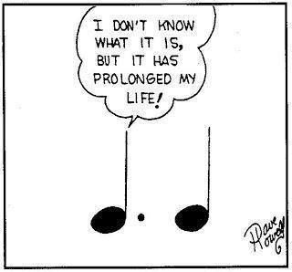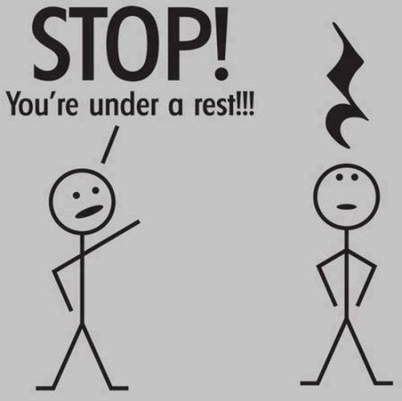
~~~~~~~~~~~~~~~~~~~~~~~~~~~~~~~~~~~~~~~~~~~~~~~~~~~~~~~~~~~~~~~~~~~~~~~~~~~~~~~~

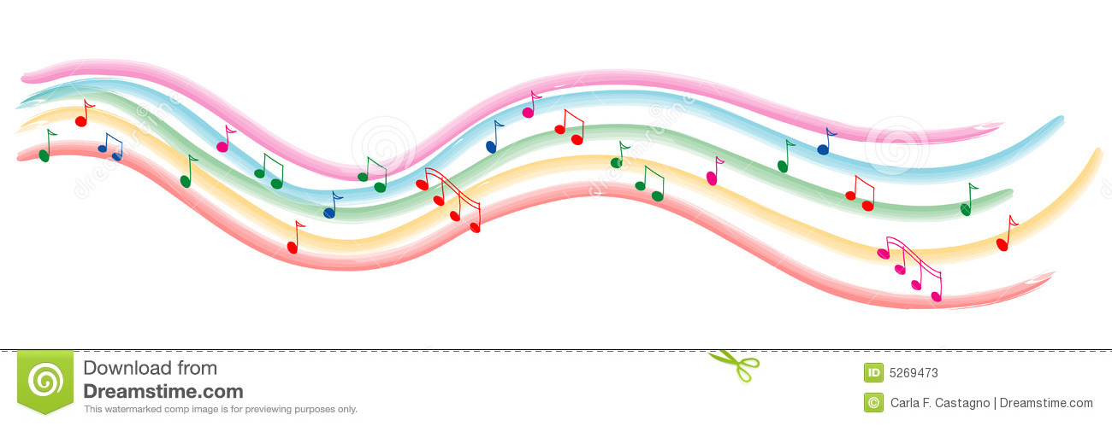
Please be aware that some events may be postponed or even cancelled due to changes in the Covid19 Levels that may occur from time to time.
We will let you know if anything does change and will keep you informed with the effect it has on the Folk Club activities.

~~~~~~~~~~~~~~~~~~~~~~~~~~~~~~~~~~~~~~~~~~~~~~~~~~~~~~~~~~
We currently have NO concerts scheduled, but we hope to have some bookings coming in – we will keep you posted

EVENTS CALENDAR Feb – June 2021
Unless otherwise stated our door charge is: $3 members; $5 non-members;
School aged children & ‘First-timers’ FREE

VENUE: The Theosophical Hall, 304 Church St (between Linton and Pitt St)
Complimentary supper around 9pm.
See us online at: http://pnfolkclub.weebly.com/
FEB  Fri 26th | 8pm: Whiteboard Concert:– come and play your best tune or song  Come along and put your name on the board, or come for a listen... | Host: Craig  Supper: Nigel  Door: David
MARCH  Fri 5th | 8pm: Old Standards: Popular and enduring songs and tunes from all eras. | Host: Mike O  Supper: Ruth  Door: David
Fri 12th | 8pm: Mistakes: Mistaken identities, false lovers, poor life choices, etc | Host: Rosemary  Supper: Midge  Door: Lesley
Fri 19th | 8pm: St Patrick’s Day celebrations: Bring along a bit of the Irish luck and charm for a great night of music from over the oceans… | Host: Nigel  Supper: Craig  Door: Lesley
Fri 26th | 8pm: Travelling and Journeys: “On the road again” songs and bring along the songs you sang in the car while going on family holidays… | Host: David  Supper: Cathy  Door: Di
APRIL  Fri 2nd | NO FOLK CLUB – it’s EASTER Weekend
Fri 9th | 8pm: Songs of the 70’s: There are a lot of great hits from the 1970’s with a trip down memory lane for a lot of us! | Host: Ruth  Supper: Dianne  Door: Bob F
Fri 16th | 8pm: AGM – come along and have your say on how the club is run  – join the committee and get things happening!!!  – followed by a JAM session | Host: Craig  Supper: Committee  Door: Free
Fri 23rd | 8pm: ANZAC: “At the going down of the sun and in the morning,  - we will remember them..” | Host: Bruce  Supper: Mike O  Door: Craig
Fri 30th | 8pm: Celtic night: A great opportunity to dust off those celtic tunes and songs that we most enjoy… | Host: Nigel  Supper: Lis & Arthur  Door: Mike P
MAY  Fri 7th | 8pm: Humorous songs: It is always a good time to have a laugh – bring music a long that will have us in stitches and leave us with a smile on our face | Host: Roy  Supper: David  Door: Bruce
Fri 14th | 8pm: Towns and Cities: See what you can dig up that has to do with towns and cities, there are a lot of good tunes out there! | Host: Di  Supper: Ruth  Door: Midge Midge
Fri 21st | 8pm: Autumn Tones: Show us all the colours of autumn in song and music | Host: John Salisbury  Supper: Trevor & Chris  Door: David
Fri 28th | 8pm: Australasia: All things New Zealand and Australia are on for tonight | Host: Mike O  Supper: Craig  Door: Ruth
JUNE  Fri 4th | NO FOLK CLUB – it’s QUEEN’S BIRTHDAY Weekend
Fri 11th | 8pm: Bluegrass & Old Time Music: Come and join in with some  toe-tappin’, hand-clappin’, foot-stompin’ good music! | Host: Keith Hollis  Supper: Cheryl  Door: Cash
Fri 18th | 8pm: Whiteboard Concert:– come and play two of your best tunes or songs. Come along and put your name on the board!!! | Host: Nigel  Supper: Dianne  Door: Lesley
Please check for your name in the programme above, highlight your duties and mark your calendar
- If you are rostered on for supper duty, please bring milk and two kinds of biscuits (bring your receipt to the Treasurer/door person to be reimbursed for the costs)
- If you are unavailable for your rostered duty please arrange a replacement and contact a committee member or email palmyfolkclub@gmail.com
- Hall phone number is 353 2310 if you need to cancel at very short notice or are running late
- If you would like to be included in future rosters please email: palmyfolkclub@gmail.com

